Data Science Tool Mastery Project
Data Analyst Internship Task 4 of 6
Programme dates 10 October 2026 to 5 December 2026

Scope
This portfolio demonstrates Python, NumPy, Pandas, Matplotlib, SQLite and scikit-learn in one reproducible workflow. Each tool has a concrete responsibility and an inspectable output, rather than only a theoretical explanation.

Python NumPy and Pandas
Python functions encapsulate repeated work and pathlib manages file paths. NumPy calculates vectorized statistics and prediction errors. Pandas loads CSVs, audits schema, filters records, calculates grouped summaries and exports results. Notebook 04 compares NumPy target means with Pandas values to check agreement.

SQL implementation
SQLite stores the clean frame in a diabetes table. sql/analysis.sql includes record counts, average target scores, BMI group summaries and high-target records. outputs/analysis.sqlite is the runnable database. outputs/sql_summary.csv and sql_bmi_groups.csv capture query results. SQL is executed in-process with sqlite3, avoiding a separate database server.

Visualization practice
Matplotlib creates labelled histograms, scatter plots, correlation bars, box plots and residual charts. Save figures at reproducible sizes and name files consistently. Check axis units before interpreting relationships. Charts are used to answer specific questions and are included in the reporting deliverables.

Modelling tools
scikit-learn pipelines combine median imputation, standard scaling and regression. Even though the audited source has no missing cells, fitted preprocessing provides a reusable workflow. Five shuffled training folds compare a dummy mean baseline, linear regression, ridge regression and random forest. The final hold-out is reserved for evaluation.

Portfolio evidence and conclusion
The notebooks, scripts, SQL queries, data dictionary, requirements and outputs together form the portfolio. The README maps files to tasks and explains installation and GitHub publication. Tool proficiency is demonstrated through executed examples; Power BI or Excel files are not claimed as outputs of this package.

References and reproducibility
https://scikit-learn.org/stable/modules/generated/sklearn.datasets.load_diabetes.html
Dataset notes and original study attribution are in data/SOURCE.md. The README explains setup, task mapping and submission. Report values are computed outputs, not proof of clinical validity.

Visual evidence
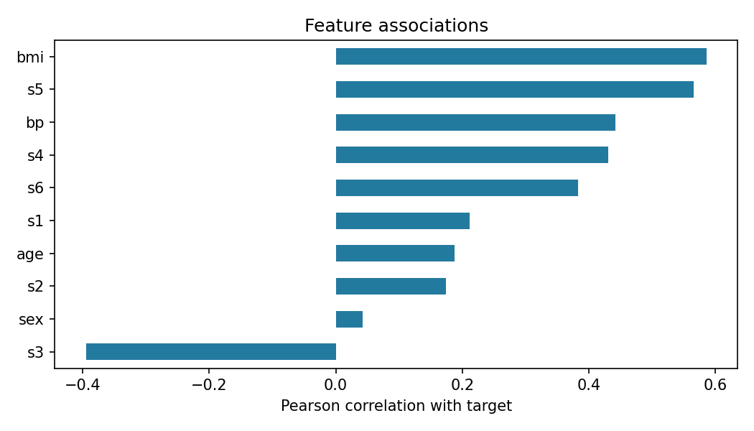
Correlation bars are descriptive and are not causal feature effects.

Computed evidence
Rows 442 Missing cells 0 Duplicate rows 0
Target mean 152.13 Target median 140.50
Complete tables and chart generation are available in outputs and src.

